RESEARCH FOR YOUR GENRE STORY
- OPEN CORKULOUS. Delete all of the notes/cards/post its on the single cork board on your screen. You should have a blank board. Open the drawer on the bottom of the board and notice the cards/post its/notes available for you to use.
- Set up three post its on the top of your screen. Your three research topics should be written on these three post its. One research topic should be the SETTING; the other two should be your choice. Like this:
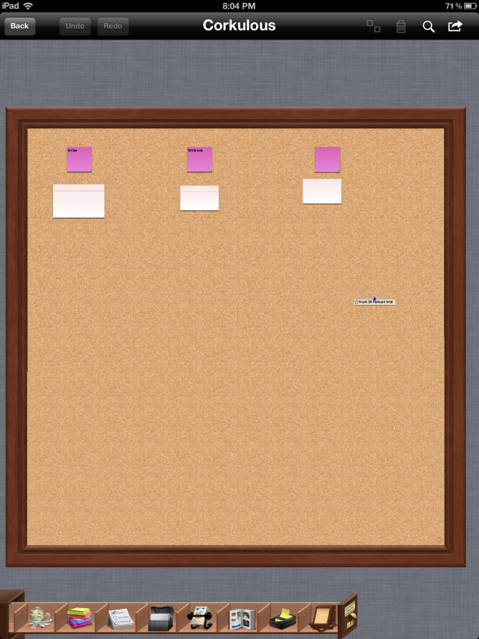

- Under each of these post its, you will create a WORKING OUTLINE for that research topic. A working outline helps you organize the information that you want to find out through your research. You can add and subtract information as necessary during the research process. You can put an index card or another post it under your research topics with a list of information that you want to know. Like this:
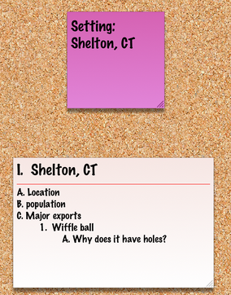
- You will create a working outline like the one above for each of your three post its.
ONCE WE START RESEARCHING:
- After you find a source with information you can use for your paper, the FIRST THING YOU MUST DO is save the information on a bibliographical card. You will create a new index card on your CORK BOARD with bibliographic information. You may want to make your bibliographic cards different colors than you working outline cards and your actual research cards.
  - The information needed for your cards is below:

FOR BOOKS:
-Author/Author’s first and last name (if there are authors)
-Complete title from title page, underlined
-Place of Publication
-Publisher
-Copyright date

FOR INTERNET SITES:
-Author/Authors’ first and last name (if the authors are given)
-Article title, surrounded by quotation marks
-title of website
-Any version numbers, such as posting dates, revision dates
-Page number (if given)
-Date you accessed the site
-website address (URL)

FOR NEWSPAPER AND MAGAZINE ARTICLES:
-First and last name of author/authors, if given
-Title of article, in quotation marks
-Name of magazine or newspaper, underlined
-Date
-Page numbers
A bibliographic card for a website might look something like this:
- Once you have a book/internet site/article you want to use, you can then start a new note card under the card with the RESEARCH INFORMATION. You can then write information on that card that you have discovered in relation to your research topic (remember you are working from your working outline).
A completed RESEARCH CARD might look something like this:
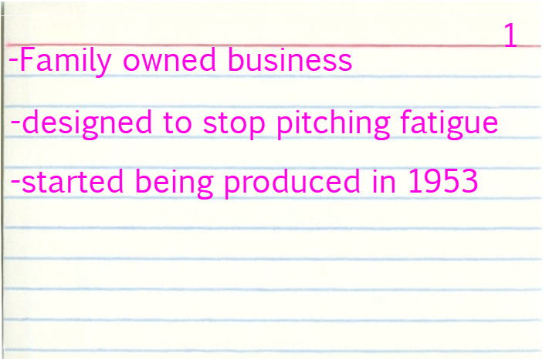

3. You need to have AT LEAST one book and two online resources for this project. You may have more than those three sources though.
4. You will be responsible for completing TWENTY FIVE cards total by the end of the research portion of this project.

***Note: All research cards and bibliographic cards should be compiled on your CORKULOUS cork board for my review each week.

